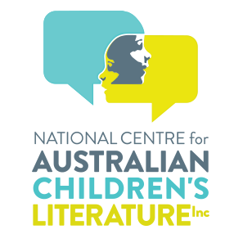
BOB GRAHAM - LIFE MEMBERSHIP OF THE NATIONAL CENTRE FOR AUSTRALIAN CHILDREN’S LITERATURE INC.AS CONFERRED BY THE BOARD
Life Membership conferred on Bob Graham by the Board is the highest Award available to recognise Bob’s exceptional contribution to the National Centre for Australian Children’s Literature Inc (NCACL).
Bob has demonstrated significant, sustained, and high-quality service enhancing the reputation and vision of the NCACL through:
- his close engagement with and generosity to NCACL over many decades;
- his sustained friendship reflecting a passionate dedication to the values of the NCACL;
- his exemplary advocacy is reflected in his making his body of work available for research with the NCACL.
Today, publishers, authors and illustrators communicate electronically by email and by virtual conferencing platforms.
Capturing the creative process is difficult as authors and illustrators may not be aware of the necessity to electronically archive and share their creative processes. It is extremely difficult for the National Centre to capture their creative processes. However, more publishers, authors and illustrators are resorting to podcasts and Youtube presentations about their works.
By making his significant body of work available to researchers, Bob has ensured that his creative processes have been captured for future generations.

