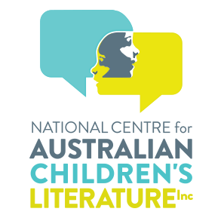
ROSE HOWES - LIFE MEMBERSHIP OF THE NATIONAL CENTRE FOR AUSTRALIAN CHILDREN’S LITERATURE INC.AS CONFERRED BY THE BOARD
Life Membership as conferred to Rose Howes by the Board is the highest Award available to recognise her exceptional contribution to the National Centre for Australian Children’s Literature Inc (NCACL).
Rose has demonstrated significant, sustained, and high-quality service enhancing the reputation and vision of the NCACL through:
- her service of over 30 years to the NCACL (including its original iteration of the Lu Rees Archives);
- her attitude reflecting a dedication to the values of the NCACL;
- her leadership (especially over local, national and international 24/7 access to the NCACL’s collection records through its catalogue) and;
- her ongoing active advocacy of the NCACL through access to its collection.

Rose has spent over 30 years dedicating herself to the activities of the NCACL. She has a passion for Australian children's literature, its publishers and its creators. Her work with first the Lu Rees Archives which became the National Centre for Australian Children's Literature draws on these passions, skills and experience. She enjoys the work, which involves collecting, organising, preserving and sharing the collection with future generations.

NCACL catalogue records have been contributed to the National Library of Australia’s Trove catalogue and World Cat. Electronic cataloguing records are now shared worldwide with locations of resources embedded.
The NCACL’s mission<https://www.ncacl.org.au/mission/> is to collect, document and preserve Australian childrens books and literature. It aims to share the collection with all Australians through outreach activities. In order to reach national and international audiences, resources are available online. Its Objects are specifically outlined<https://www.ncacl.org.au/bequests/ncacl-objects/>.
In this regard, Rose has excelled.

