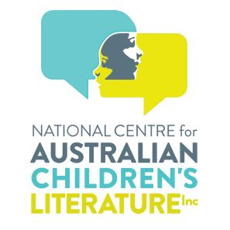
NATIONAL CENTRE FOR
AUSTRALIAN CHILDREN’S LITERATURE BOARD

AWARDS
Maxwell Brown
LIFE MEMBERSHIP

FOR HIS OUTSTANDING CONTRIBUTION
TO THE CENTRE’S MISSION

…………………………………………….
Dr Belle Alderman AM
ON BEHALF OF THE BOARD

