

Australian Picture Books with Neurodiversity and Disability themes
Annotated Bibliography

Children's literature serves many purposes, including functioning as mirrors that reflect a reader's own life, providing a lens into their identity, passions and talents. Stories can also be used as windows into other people’s lives, offering different perspectives to build empathy, understanding and inclusion, before finally acting as a sliding doors for readers to step into the shoes of their favourite characters to experience their successes and challenges as if they were the characters themselves. For neurodivergent children and people with disabilities, authentic representation in picture books is important to support both their self-worth and to build understanding within the community to foster inclusion.

This annotated bibliography has a curated collection of contemporary Australian picture books, with some seminal texts included, that have authentic representation of characters with either disability or neurodiversity themes. Through selecting different picture books that offer representation in these areas, children, families, teachers and the wider community can use these books as mentor texts to ensure authentic discussion around unique lives and perspectives can occur and every child can feel seen and empowered.

Curated by: Sarah Paterson

Neurodiversity:
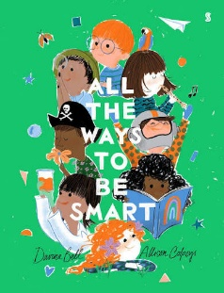 | BELL, Davina. Illustrated by Allison Colpoys  All the Ways to Be Smart. Scribble, 2022. ISBN: 9781925713435  This picture book explores traditional definitions of intelligence beyond academic to celebrate social and emotional, artistic, physical, and neurodivergent talents. It fosters self-esteem and inclusion, reminding young readers that everyone shines in their own unique way.
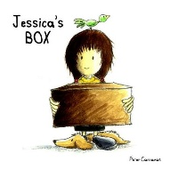 | CARNAVAS, Peter. Illustrated by Peter Carnavas  Jessica's Box. New Frontier Publishing, 2013. ISBN: 9781921928574  Jessica is a young girl facing the anxiety of starting school and trying to figure out how to make friends. She carries a large cardboard box to school to try and help her manage her worry, before realising that she doesn't need props to be accepted, she can just be her authentic self.
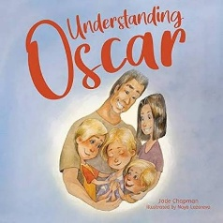 | CHAPMAN, Jade. Illustrated by Naya Lazareva  Understanding Oscar. Little Steps Publishing, 2021. ISBN: 9781922358899  A touching story told from the perspective of brothers learning to understand life with their sibling with autism. It carefully considers the unique daily challenges with close family relationships, offering a wonderful narrative text for siblings and families of neurodivergent children.
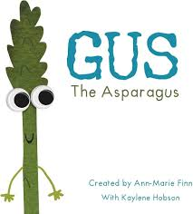 | FINN, Ann-Marie. Illustrated by Kaylene Hobson  Gus the Asparagus. Yellow Brick Books, 2018. ISBN: 9780994557063  Inspired by real-life experiences with Asperger's syndrome, this charming story follows Gus, an asparagus, who thinks and behaves differently from those around him. When he goes to school, he struggles to fit in until he sees a doctor who brings understanding and relief, offering an uplifting look at neurodivergent traits.
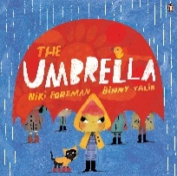 | FOREMAN, Niki. Illustrated by Binny Talib  The Umbrella. Penguin Books, 2026. ISBN: 9781761348242  A timely picture book about a child struggling to fit into traditional neurodivergent ‘umbrellas’, offering a powerful validation of finding one's own sense of identify and belonging beyond a diagnosis.
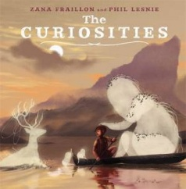 | FRAILLON, Zana. Illustrated by Phil Lesnie  The Curiosities. Lothian Children's Books, 2021. ISBN: 9780734417848 Inspired by neurodivergence, this expressive story follows a boy whose physical and emotional ‘curiosities’ nest on him, beautifully celebrating those who see and experience the world differently.  https://www.ncacl.org.au/pbor-database/the-curiosities/
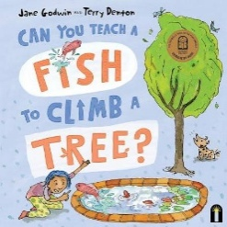 | GODWIN, Jane. Illustrated by Terry Denton  Can You Teach a Fish to Climb a Tree? Bright Light Books, 2023. ISBN: 9781760508661  An inspiring picture book that questions social norms and celebrates difference and neurodiversity. By looking at what different animals (and babies) are naturally talented at, it encourages young readers to appreciate their own unique strengths and passions.
 | GRAHAM, Alexander Brett. Illustrated by Marwarini  Winnie's Tasty Tomatoes. Era Publications, 2015. ISBN: 9781863745123  This picture book embraces difference, featuring a character who has communication and processing differences, using a gardening theme of different plant needs to explore neurodiversity, while showing younger readers there is someone available to help when challenges arise.
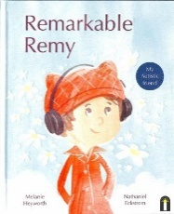 | HEYWORTH, Melanie. Illustrated by Nathaniel Eckstrom  Remarkable Remy. Hardie Grant Children's Publishing, 2023. ISBN: 9781761210372  This picture book follows a boy with autism through his daily life, celebrating his unique perspective and outside of the box thinking. It includes themes of friendship with neurodiverse children and how looking at the world differently can be ‘remarkable’.
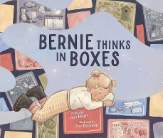 | HORN, Jess. Illustrated by Zoë Bennett  Bernie Thinks in Boxes. Affirm Kids, 2024. ISBN: 9781922930033  Authored by a neurodivergent writer, this picture book follows Bernie, who likes to organise her world into neat boxes, showing the reader a picture of her brain’s organisation. When changes in daily life cause her boxes to collide, Bernie must work though how she can be more flexible in her thinking. The story offers a sensitive, neuro-affirming narrative to navigating transitions and flexible thinking.
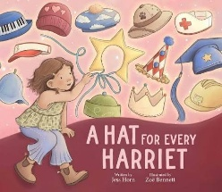 | HORN, Jess. Illustrated by Zoë Bennett  A Hat for Every Harriet. Affirm Press, 2026. ISBN: 9781923293243  A neuro-affirming story about a young girl who struggles with masking and trying to fit into expectations, ultimately learning to shed her many ‘hats’ to embrace her authentic self. This narrative supports students who feel they need to change to fit in, before finally learning to be your true self.
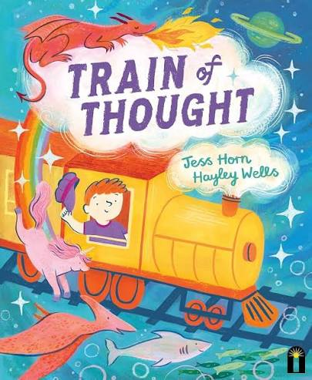 | HORN, Jess. Illustrated by Hayley Wells  Train of Thought. Hardie Grant Children's Publishing, 2025. ISBN: 9781761214301  An imaginative picture book that explores neurodivergence through Andy, a boy with a brilliant imagination, that takes him far away from the real world. It provides an affirming representation of imaginative worlds and strategies to help children focus their mind, supporting a lens to celebrate how we all have a creative imagination and how we can all be the ‘drivers’ on our thought train.
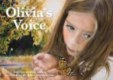 | LUCAS, Mike. Illustrated by Jennifer Harrison  Olivia's Voice. MidnightSun Publishing, 2017. ISBN: 9781925227192  A sensitive story exploring hearing impairment and communication through the perspective of a young girl named Olivia. The book highlights how children navigate sensory differences and find their unique ways of expressing themselves and connecting with others.
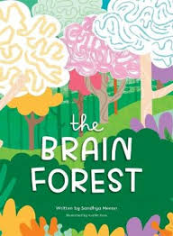 | MENON, Sandhya. Illustrated by Kushla Ross  The Brain Forest. Onwards and Upwards Psychology, 2022. ISBN: 9780645977325  Using a forest analogy, this book introduces children to the idea of neurodiversity by showing how different types of trees grow, think, and experience the world. It provides an imaginative starting point as a mentor text to discuss why others might think or behave differently.
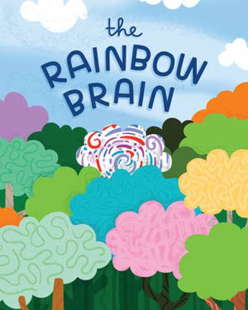 | MENON, Sandhya. Illustrated by Kushla Ross  The Rainbow Brain. Onwards and Upwards Psychology, 2023. ISBN: 9780646876054  An award-winning picture book designed to explore what it means to be ‘AuDHD’, which is someone who has an ADHD and autism profile. It explains to children how to balance the needs of both autism and ADHD while celebrating their neuro-divergent identity; as the author says, “like peanut butter and jam - yummmmm”.
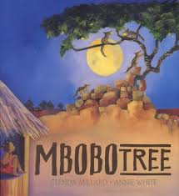 | MILLARD, Glenda. Illustrated by Annie White  Mbobo Tree. Scholastic, 2009. ISBN: 9781741693515  A touching story about a little girl named Tiranamba who is discovered on a tree that the village believes is ‘magical’. Tiranamba never speaks a word to the villagers, and when her community is threatened, she finds a way to save the special tree, becoming legend herself. A narrative that celebrates non-verbal communication, with a hint of magic.
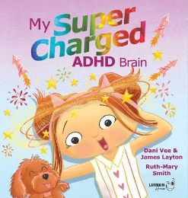 | VEE, Dani, & LAYTON, James. Illustrated by Ruth Mary Smith  My Supercharged ADHD Brain. Larrikin House, 2025. ISBN: 9781923345041  Created by neurodivergent authors, this energetic picture book explores the dynamic strengths and everyday hurdles of living with an ADHD brain. It acts as a joyful tool to help children understand their cognitive differences and build self-acceptance.
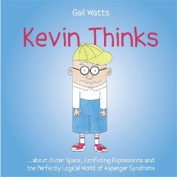 | WATTS, Gail. Illustrated by Gail Watts  Kevin Thinks. Jessica Kingsley Publishers, 2012. ISBN: 9781849052924  A boy with autism shares his ‘out of the box’ thoughts and opinions about life, offering a window into neurodivergence and helping readers appreciate diverse ways of thinking.

Disability:
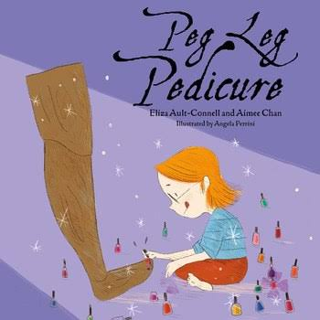 | AULT-CONNELL, Eliza. Illustrated by Angela Perrini  The Peg Leg Pedicure. Little Steps Publishing, 2022. ISBN: 9781922358424  Written by a disability advocate, this story offers a window into a child with limb difference and prosthetic use. Through the fun, everyday experience of painting nails, this picture book provides young readers with a positive message for physical disability and body diversity.
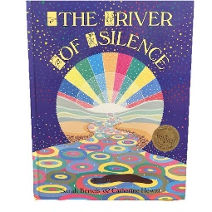 | BERTELS, Sarah. Illustrated by Catherine Hewitt  The River of Silence. Lothian, 1990. ISBN: 0850914000  Using colourful illustrations and accompanied by pictures of sign language hand gestures of the words within the text, this seminal book tells the story of a river searching for its sound. It delivers a powerful message that hearing is not required to perceive beauty in the world, while teaching readers how to sign the story as they move through the text.  https://www.ncacl.org.au/pbor-database/the-river-of-silence/
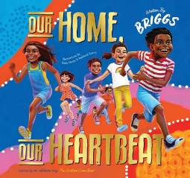 | BRIGGS, Adam. Illustrated by Kate Moon and Rachael Sarra  Our Home, Our Heartbeat. Little Hare Books, 2020. ISBN: 9781760504168  Adapted from the celebrated song, ‘The Children Came Back’, this vibrant picture book honours First Nations culture, history, and community, while inclusively recognising diverse abilities through authentic representation in the illustrations.  https://www.ncacl.org.au/atsi_resource/our-home-our-heartbeat/
 | BRISLAND, Toni. Illustrated by Michele Gaudion  The Tree House. Little Steps Publishing, 2014. ISBN: 9781925117011  Emma dreams of helping her sister Teresa climb the tree to enjoy the treehouse with her wheelchair. The story follows how the sister never gives up to ensure Teresa can enjoy the treehouse with her. This story highlights a sibling bond, problem solving and physical disability with hope and imagination.
 | BRZEZINSKI, Monica. Illustrated by Brian Tisdall  Ellie's Walk. Remi & Monica Brezinski, 2004. ISBN: 0958164134  A young girl who is blind experiences a walk through her neighbourhood, showing the reader her perceptions as she moves through her local area. Readers will love joining Ellie on her sensory walk as she uses her cane and other senses to experience the sounds, smells, and textures of her community.
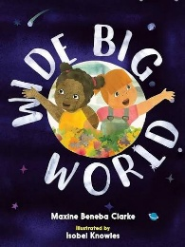 | CLARKE, Maxine Beneba. Illustrated by Isobel Knowles  Wide Big World. Lothian Children's Books, 2018. ISBN: 9780734420503  A vibrant picture book that looks at the rich tapestry of human diversity across the globe. It encourages young children to notice, respect, and celebrate differences in appearance, ability, and lifestyle as normal parts of our community.  https://www.ncacl.org.au/cd-database/wide-big-world/
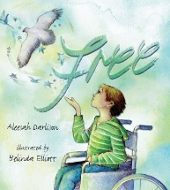 | DARLISON, Aleesah. Illustrated by Belinda Elliott  Free. Empowering Resources, 2017. ISBN: 9781925592085  Following a life altering accident, Flynn navigates the emotional and physical adjustment of using a wheelchair. With the help of his Mum and close friends, he discovers freedom beyond his own preconceived barriers, celebrating resilience and inclusion.
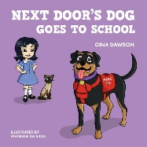 | DAWSON, Gina. Illustrated by Vivienne da Silva  Next Door's Dog Goes to School. New Holland Publishers, 2018. ISBN: 9781760790523  Grace uses a service dog named Roxie to help her attend school and navigate daily life. This book explores the vital role of medical response and service dogs, teaching readers about inclusion, independence, and disability.
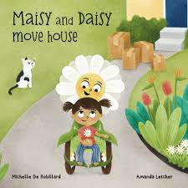 | DE ROBILLARD, Michelle. Illustrated by Amanda Letcher  Maisy and Daisy Move House. Michelle de Robillard, 2024. ISBN: 9780645959918  Written by a physiotherapist, this delightful picture book follows a young girl named Maisy who uses a wheelchair (whom she affectionately calls Daisy) as she navigates the accessibility issues involved in moving to a new home. It provides a wonderful springboard for discussing disability, inclusion, and the importance of accessibility in the home and wider community.
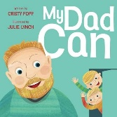 | FOPP, Cristy.  My Dad Can. Green Hill Publishing, 2025. ISBN: 9781923386396  This picture book celebrates all the wonderful things fathers can do regardless of physical abilities. It focuses on positive attitudes, and resilience determines how someone lives and accesses the world around them, with this book being an excellent mentor narrative to explore the themes of capability and adaptation.
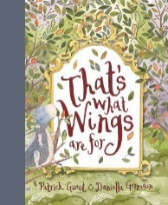 | GUEST, Patrick. Illustrated by Daniella Germain  That's What Wings Are For. Little Hare Books, 2015. ISBN: 9781742978291  A young dragon who lacks the ability to fly because of his different wings discovers different strengths he can give his friends. This story provides an empowering mirror for children with muscular dystrophy and other physical disabilities.
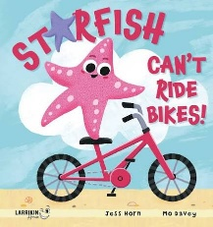 | HORN, Jess. Illustrated by Mo Davey  Starfish Can't Ride Bikes! Larrikin House, 2026. ISBN: 9781923345386  A witty, original look at accessibility when a starfish challenges the idea of limitations when he realises he cannot ride a bike, reframing the issue to focus on inclusive design and problem solving attitudes.
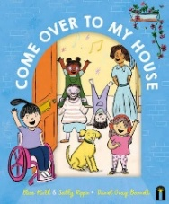 | HULL, Eliza. Illustrated by Sally Rippin  Come Over to My House. Victoria Bright Light, 2022. ISBN: 9781761210082  Children invite readers into their homes, showing accessible modifications and disability aids that they use. This picture book includes many different types of disabilities, offering a wonderful window into inclusive, everyday family life.
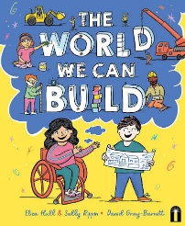 | HULL, Eliza & RIPPIN, Sally. Illustrated by Daniel Gray-Barnett  The World We Can Build. Hardie Grant Children's Publishing, 2025. ISBN: 9781761213601  Two children dreaming up accessible neighbourhoods provide a mirror and window for exploring physical disability, with a focus on community inclusion.
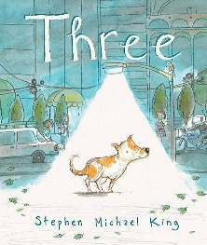 | KING, Stephen Michael.  Three. Scholastic Australia, 2019. ISBN: 9781760664053  A heartwarming picture book about a stray dog named Three, who has only three legs. The story offers young readers a joyful, accessible message about physical difference, resilience, and finding a sense of belonging.
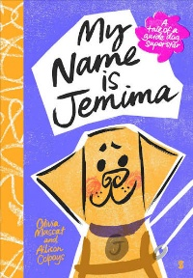 | MUSCAT, Olivia. Illustrated by Allison Colpoys  My Name is Jemima. Scribble: Scribe Publications, 2025. ISBN: 9781761380457  Authored by a blind disability activist, this engaging picture book is told from the perspective of Jemima, a fully trained guide dog. It offers a view to the special bond between a handler and a guide dog, teaching children respectful interactions around working assistance animals in public spaces, providing them the space needed to do their ‘job’.
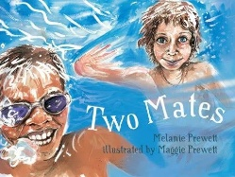 | PREWETT, Melanie. Illustrated by Maggie Prewett  Two Mates. Magabala Books, 2012. ISBN: 9781921248450  Based on a true story, this seminal book follows the close friendship between two boys growing up in Broome, WA, one who is from a First Nations country and another who has spina bifida and uses a wheelchair. Highlighting Raf's wheelchair only at the end of the story, this inclusive narrative emphasises that adventures and true friendship is always possible.  https://www.ncacl.org.au/atsi_resource/two-mates/
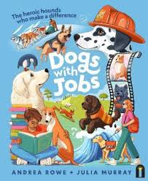 | ROWE, Andrea. Illustrated by Julia Murray  Dogs with Jobs: The Heroic Hounds Who Make a Difference. Hardie Grant Children's Publishing, 2025. ISBN: 9781761213991  A non-fiction picture book that showcases remarkable working dogs throughout different parts of the community. It includes assistance and therapy dogs that support individuals with physical disabilities, medical conditions, and neurodivergence, illustrating the vital roles animals play for people with a disability.
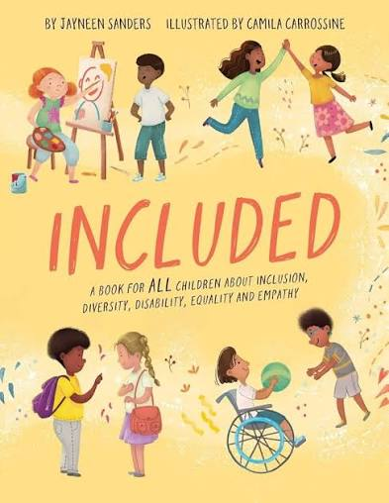 | SANDERS, Jayneen. Illustrated by Camila Carrossine.  Included. Upload Publishing, 2022. ISBN: 9781925089752  This engaging picture book introduces children with a diverse range of physical and neurodivergent experiences, including cerebral palsy, autism, ADHD, Down syndrome, deafness, and limb differences. It shows that all children want to play and have fun, while offering practical ways young readers can include others in their activities through an inclusive lens.
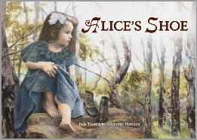 | THORNDYKE, Julie. Illustrated by Jennifer Harrison  Alice's Shoe. MidnightSun Publishing, 2023. ISBN: 9781922858139  This historical picture book tells the story of Alice Betteridge, the first deaf and blind person to be sent to mainstream school in Australia, showcasing her determination and way of ‘seeing’ the world around her. It offers young readers an inspiring look at resilience, communication, and other ways of experiencing with the world.  https://www.ncacl.org.au/pbor-database/alices-shoe/
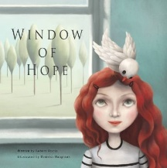 | VESCIO, Robert. Illustrated by Demelsa Haughton  Window of Hope. Little Pink Dog Books, 2019. ISBN: 9780648256366  This picture book follows a young girl who is isolated by her disability, but finds connection and joy through a unique friendship with a little one-legged bird. It acts as a mentor text by exploring physical differences, special bonds with animals and highlights resilience.

